Hathaway High School Spirit Shirts

These school approved spirit shirts may be worn on ANY day at HHS with uniform bottoms.

SWPBIS will be selling these two designs in a 50/50 blend or dri fit.

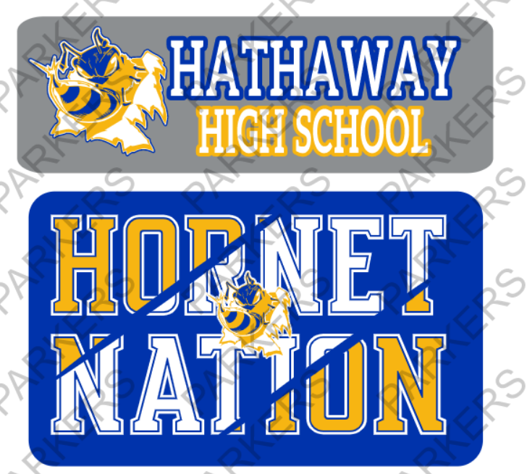

Dry blend 50/50

Youth XS- Adult XL $13.00 (add $1 per X above XL )

Dri fit

Youth XS-Adult XL $15.00 (add $1per X above XL)

Preorders will be taken in the HHS office beginning on Friday, July 29 from 8:30 am-11:30am.

Preorders will also be taken during the week of August 1st - 4th in the HHS office from 8:30 am-2:30pm. The deadline to preorder is August 4th at 2:30pm.

Preordered shirts will be able to be picked up at Back to School Night on August 10th. We will have a limited supply of shirts to sell that night. We will also be able to take orders at Back to School Night, but those shirts will not be ready for the first day of school.

The HHS Varsity Cheerleaders are also selling spirit shirts that are approved to be worn at school on ANY day with uniform bottoms. Please visit the link below for information on these shirts and to place your order.

https://tshirtshopjennings.com/collections/hhs-spirit-22-23

**22-23 Spirit Shirt Order Form**



Student Name _______________________________________________

Grade ___________

**Please place the quantity ordered for each shirt size.**

**Grey Hathaway High School shirt**  **_____ 50/50 blend ($13.00) _____ Dri fit ($15.00)**

__ YXS __YS __YM __YL __AS __AM __AL __AXL

**Blue Hornet Nation shirt** **_____ 50/50 blend ($13.00) _____ Dri fit ($15.00)**

__ YXS __YS __YM __YL __AS __AM __AL __AXL

Total __________

Cash____ Check______